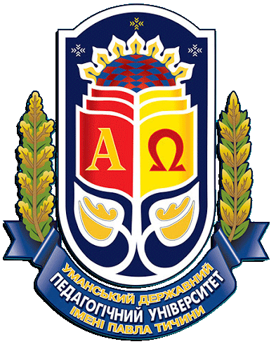**Ministry of Education and Science of Ukraine **

**Ministry of Social Policy of Ukraine**

**Ministry of Health of Ukraine**

**Ministry of Youth and Sports of Ukraine**

**Ministry of Veterans Affairs of Ukraine**

**Ukrainian State Center for National-Patriotic Education,**

**Local History and Tourism of Student Youth**

**Cherkasy Regional State Administration**

**Cherkasy regional council**

**Cherkasy Regional Center for Medical and Social Expertise**

**Pavlo Tychyna Uman State Pedagogical University**

**Uman City Council**

**Department of Labor and Social Protection**

**Public Union "All-Ukrainian Union of Public Organizations**

**"Confederation of public organizations of the disabled"**

**Association of Inclusive Rehabilitation and Social Tourism**

INFORMATIONAL LETTER OF THE 2d INTERNATIONAL SCIENTIFIC AND PRACTICAL SYMPOSIUM

ON INCLUSIVE TOURISM

*May* ________ , *2021*

**Main directions of the conference:**

*1. Technologies of social work with persons with disabilities.*

*2. Social and psychological rehabilitation of persons with disabilities by means of inclusive tourism.*

*3. Nature therapy in the context of socio-psychological rehabilitation of people with disabilities*

*4. Best practices of implementation of inclusive-rehabilitation-social tourism in Ukraine*

**The symposium will be held online using the ZOOM system**

(The online broadcast of the symposium will be available for everyone without prior registration on the faculty's Facebook page. Participants will be able to ask questions to the speakers in the comments under the broadcast.)

Leading domestic and foreign scientists and practitioners are scheduled to participate in the conference.

|  |  |
| --- | --- |
| **Important dates:**  *___ April* – deadline for submission of materials;  *___ May* – holding a conference. | Working languages of the conference: Ukrainian, Polish, English.  **Publication of the collection of scientific papers** is planned for the beginning of the conference |

To participate in the conference, please till April _____, 2021:

1. Fill out the application <https://forms.gle/3w8UEaxRNdxJW5y29>

2. Send abstracts to e-mail [katarinka_chupina@ukr.net](mailto:katarinka_chupina@ukr.net) marked "THE 2d SCIENTIFIC AND PRACTICAL SYMPOSIUM ON INCLUSIVE TOURISM"

**Requirements for the design of abstracts:**

Materials of conference abstracts are submitted in electronic form and must meet the following requirements: extension .doc, .docx, font type - TimesNewRoman; font size - 14; the length of abstracts 2-5 pages of printed text, without page numbering, format A4; line spacing - 1,5; margins: left, bottom, top, right - 20 mm.

**The order of the material placement:**

In the upper right corner (alignment on the right edge) - the author's initials (before the surname) and surname are printed in bold, then - a summary of the main material of the thesis, a list of references.

There is also an opportunity to publish the results of research in the professional journal **"Social Work and Social Education"**

**\* The collection of the conference is indexed by scientometric databases:**

The collection is included in Category B of the List of scientific professional publications of Ukraine, which can publish the results of dissertations for doctoral and PhD degrees (pedagogical branch of knowledge, specialties: 011, 015, 016, 231). Order of the Ministry of Education and Science of Ukraine from 26.11.2020 № 1471.

- ISSN InternationalCentre, Paris;

- CrossRef;

- GoogleScholar;

- IndexCopernicus;

- WorldCat (USA);

- Ukrainian scientific and educational network URAN;

- V.I. Vernadskyi National Library of Ukraine;

- BielefeldAcademicSearchEngine (BASE)

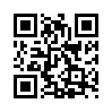

Information about the journal

**CONTACTS:**

**Address of the organizing committee**: Uman, 28 Sadova Street, Department of Social Pedagogy and Social Work.

**E-mail:** [**okskravchenko@ukr.net**](mailto:okskravchenko@ukr.net)

**For inquiries: +380984216444 (Oksana Kravchenko)**